Alaska Indoor Gardening Curriculum

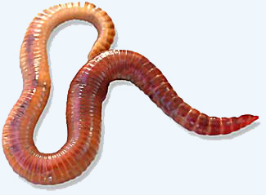
Composting Worms Lesson

Author(s)/Source: Mel Sikes, Alaska Ag in the Classroom

Suggested Grade Levels: K-8th grade

Time: 40-45 minutes

Teaching Goal: Students will learn about the structure of composting worms and how they function. Students will investigate how composting works both with worms and without worms.

Learning Objectives:
To explore the red wiggler structure and life cycle and how castings are made by worms.
To learn how vegetable matter is turned into compost.

Core Topics:
- Introduction to Composting
- Life Cycle and Anatomy of Worms
- Decomposition of Vegetation
- Composition of Compost (Macro and Micro Organisms, Oxygen and Aeration, Temperature)
- Recording Scientific Data
- Standardized Science Measurements
- Medium Scale construction of a Compost System
- Drawing Conclusions from Experimentation (hands-on, observation, and note-taking)

Alaska State Science Standards: K-LS1-1, K-ESS3-1, K-2-ETS1-2, 1-LS1-1, 2-LS4-1, 3-LS4-3, 3-5-ETS1-1, 4-LS1-2, 5-PS3-1, 5-LS2-1, MS-LS1-3, MS-LS1-8, MS-LS2-1, MS-LS2-2, MS-LS2-5, MS-ESS3-3, MS-ETS1-1

NGSS Standards: K-LS1-1, K-ESS2-2, K-ESS3-1, 1-LS1-1, 1-LS1-2, 2-LS4-1, K-2-ETS1-1, 3-LS1-1, 3-LS3-2, 3-LS4-3, 3-LS4-4, 4-LS1-1, 4-LS1-2, 5-PS3-1, 5-LS2-1, 3-5-ETS1-1, MS-LS1-1, MS-LS1-5, MS-LS1-7, MS-LS2-4, MS-LS3-3, MS-ESS3-3, MS-ETS1-1

Materials Needed:
- Worm Booklets
- Composting Worms
- Paper Plates
- Spoons
- Magnifying glasses
- Rulers
- Worm Investigation Sheet
- Pencils
- “Diary of a Worm” by Doreen Cronin

Teachers Background Information
Red Wigglers (Eisenia fedida eye-SEN-ee-uh FE-ti-duh) are one of over 4,400 earthworm species. It is a species of earthworm adapted to decaying organic material. These worms thrive in rotting vegetation, compost, and manure. They are rarely found in soil, instead preferring conditions that are unfavorable to some other worms. They are commonly used as composting worms because they are extremely efficient. Nightcrawlers, Lumbricus terrestris, are the large subsoil dwellers commonly used for fish bait. The earthworm is one of nature’s top “soil scientists” The earthworm is responsible for a lot of the things that help make our soil good enough to grow healthy plants and provide us food.! Worms help to increase the amount of air and water that gets into the soil by creating little channels in the soil. Another interesting job that the earth worm has is that of making fertilizer. They break down organic matter like leaves and grass into things that plants can use. When they eat, they leave behind “castings” that are a very valuable type of fertilizer.

Earthworms are like free farm help! They help to “turn” the soil—bringing down organic matter from the top and mixing it with the soil below. They also tunnel deeply in the soil and bring the subsoil closer to the surface, mixing it all together. Slime, a secretion of earthworms, contains nitrogen. Nitrogen is an important nutrient for plants. The sticky slime helps to hold clusters of soil particles together.

Each earth worm – has approximately 150 segments. Each segment has 2 set of bristles called setae except the first and last segment (head and anus.) The setae extend and retract to help the worm move forward. As the body stretches forward, setae anchor it to the ground and allow the rear part of the body to catch up with it.

When roughly handled, an Eisenia fetida exudes a pungent liquid, thus the specific name foetida meaning foul-smelling. This is presumably an anti-predator adaptation.

Procedure:
- Ask students if they know what compost means? Write down their answers on the board.

- Talk about what composting is:
Composting is the process of decomposition of plant matter, turning scraps of food into soil. Successful composting is using either dark containers or animals to control the conditions so decomposition/breaking down is faster than just leaving it in a pile outdoors.

- Ask the students what they think the benefits of composting are?
Benefits include:
- Supplies beneficial insects to soil
- Improves soil structure – easier to work
- Better plant root environment – more oxygen for roots
- Supplies micronutrients such as boron, calcium, iron etc.
- Adds organic matter to soil
- Improves and stabilizes PH
- Improves C.E.C – ability to hold & release nutrients
- Erosion control
- Slow release fertilizer
- Reduces waste in landfill – Turn food scraps into fertilizer

- Talk about how compost happens:
Factors that affect composting
Microorganisms – Break down the cells of the plant material
Bacteria- Powerhouse of compost pile
Fungus – branched mycelium; causes earthy smell

Macro-organisms: Invertebrates – insects, mites, worms – eat the plants.
Their waste (poop) is fertilizer added to the compost.

Moisture – the factor that limits your compost the most
- Needed by microbes
- Provides medium for chemical reactions
- Water is lost by evaporation
- Any compost should have a balance of wetness. Not too wet, not too dry.

Oxygen and Aeration
- A compost pile or worm bin should be stirred or turned over into a new
spot regularly to add oxygen to the pile. Oxygen assists breakdown.

Structure and particle size
- Large food scraps should be cut up into smaller bits.
- Size affects breakdown rates and aeration
- The smaller the size of particles the faster the rate of breakdown

Temperature
- Too hot will kill your beneficial organism like worms.
- Ideal temperature is room temperature

- Tell students that you will be looking at worms today. Explain that worms are soil makers. Ask these questions:
- What role do earthworms play in the ecosystem? - Decomposers
- What do earthworms eat? – plant material
- How do earthworms help plants? – provide both nutrients and aeration to soil
- How do earthworms help people? – compost and aeration
- What type of habitat do earthworms need? – dark, moist soil with organic matter.

- Read the worm booklet and talk about the different parts of worms. Ask students to take notes.
Possible information to include as you read through the booklet:
Worms have a “head end” - it’s called the anterior they also have a “tail end” which is called the posterior.

When we feel worms, they are a little bit wet, or slimy. It doesn’t mean that they need a shower. Their skin is supposed to feel like that. They need moisture to survive.
You will also notice that they do not have bones, arms or legs, or eyes or teeth! They just feel sort of squishy. When you look at the worms under a magnifying glass you will see a lot of little rings across the entire body. These rings are called segments. On the first segment is the mouth. On the last segment is their bottom.

If you look really really closely, at each segment, you will see something that looks like a bunch of small hairs or bristles. These bristles are called setae (see-tee) and they help the worm move. They have 4 pair of these bristly hairs on each ring or segment.

At the very tip of their head you will see a flap of skin that hangs over their mouth. It is called the prostomium. It keeps stuff they don’t like from getting into their mouths. Their mouth is really tiny! So, they eat small things that you can’t see unless you look through a microscope. But they also like to eat organic matter such as plants, fruits, and vegetables.

Since they have no teeth, they suck their food into their mouth, and it goes into their “gizzard” As the worm eats his food small grains of sand and soil get into the gizzard and they help grind the food into tiny pieces (kind of like their own personal food processor!)

Worms have five hearts? All of the hearts pump blood through their blood vessels just like our one heart. It takes a lot of work to get where they want to go. They use their muscles and their see-tee) to move and stop.

Worms breathe without a nose or lungs? You breathe through your lungs, but worms don’t have lungs, so they breathe through their skin. They take in oxygen strait through their skin and it goes directly into their bloodstream. Their skin must stay wet in order for the oxygen to be able to pass through. Too much water will make them drown.

Worms don’t have eyes, but they can tell the difference between light and dark! They have cells in the front part of their body that are sensitive to light. And worms don’t really like the light!

Worms spend most of their time eating!!! They love fruit and vegetables! They love potato peelings, carrots, lettuce, cabbage, celery, apple peelings, banana peels, orange rinds and grapefruit. They also like cornmeal, crushed eggshells, coffee grounds and tea bags. They can’t eat meat, dairy products like cheese, milk or butter or any kind of oily food. Chopping the foods makes it easier for the worms to eat them.

- Put one or two worms and a small amount of compost on a plate for the students to observe.
- Have students use magnifiers and rulers to investigate and fill out the “Worm Investigation Sheet”.
- Be sure to tell students to be very careful and respectful of the worms.
- Set up a worm bin with your students
- If you have enough time, read “Diary of a Worm” for the students to finish.

Make a Classroom Worm Bin
Vermicomposting in your classroom is an effective way to engage students with a wide variety of science concepts. This activity will show you how to make your own worm bin out of a plastic tub. Prepare the tub ahead of time, and then have students add the bedding, worms, and vegetable scraps.

Materials
- Plastic tub with lid
- Drill with 7/8” drill bit
- Shredded paper – at least a large paper bag full
- 2-3 full sections of newspaper
- 1 small bag of garden soil
- Spray bottle filled with water
- Vegetable scraps
- Red wriggler worms

Instructions
- Drill ventilation holes 2” from the top opening of the plastic tub, space evenly all around the tub.

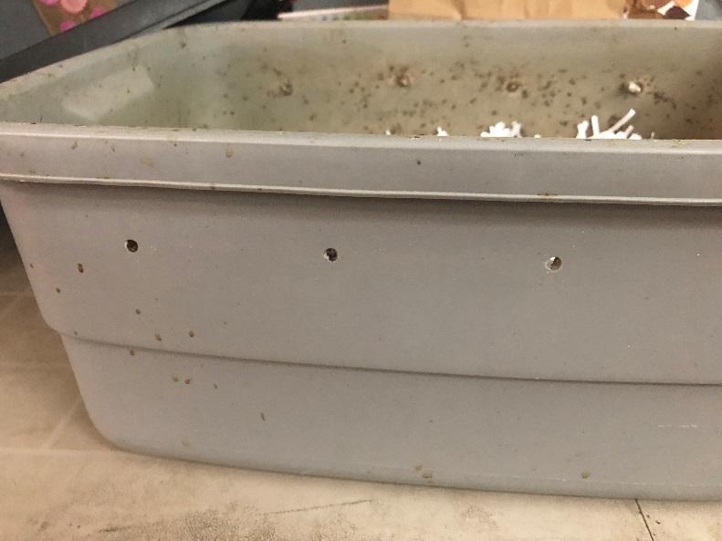

- Fill tub about half full with shredded paper.
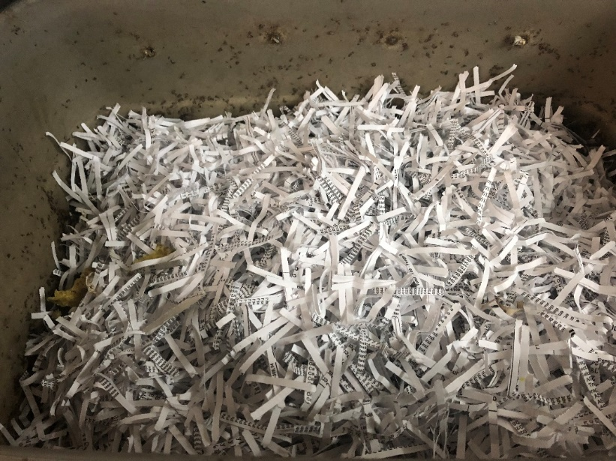

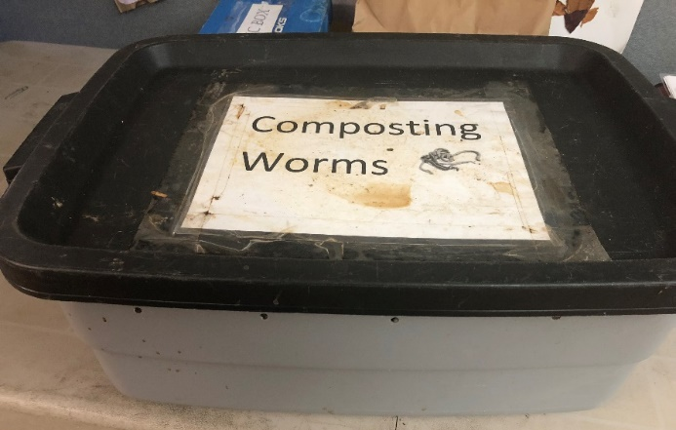
- Wet shredded paper until it is uniformly damp but not dripping. It should feel like a well wrung-out towel.
- Mix soil with shredded paper. A couple scoops with a trowel is plenty. The soil should also be moist, but not muddy.
- Add worms on top and watch as they burrow down to get away from the light.

Extensions: Garden Soil Investigation Lesson, Journaling

Assessment:
- Assess the Investigating Worms worksheet at the end of this lesson
- Develop a checklist and monitor students for participation and comprehension as the lesson progresses
- Assess their science journals
- Have them write about their process and what they learned as a self-reflection after the lesson.

Resources
Books:
The Container Expert
by Dr. D. G. Hessayon 1998 ISBN: 0-903505-43-6

Dirt
by Steve “the Dirtmeister” Tomacek 2002, 2016 ISBN: 142632362X

Gardening Indoors with Soil and Hydroponics
by George Van Patten 2007 ISBN: 978-1-878823-32-8

Improving Your Garden Soil
by Barbara Perry Lawton 1992 ISBN: 0-89721-244-4

Life in a Bucket of Soil
by Alvin and Virginia Silverstein 2000 ISBN: 0-486-41057-9

SOIL! Get the Inside Scoop
by David L. Lindbo and others 2008 ISBN: 978-0-89118-848-3

Websites:
Food and Agricultural Organization of the United Nations : http://www.fao.org/soils-2015/faq/en/

National Association of Conservation Districts: http://www.nacdnet.org/education/soils
Soil Science Society of America: http://www.soils4kids.org/

Nutrients for Life Foundation: http://www.thescienceofsoil.com/

Cornell Classroom Composting: http://compost.css.cornell.edu/worms/basics.html

